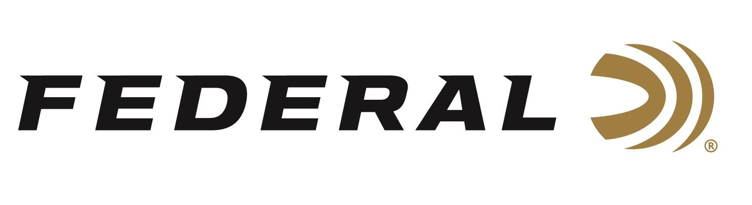

FOR IMMEDIATE RELEASE

Federal Announces a New Subsonic Rifle Ammunition Product Line
ANOKA, Minnesota – January 15, 2026 – Federal Ammunition recently announced its new Federal Subsonic rifle ammunition line designed for peak noise reduction and effective low-velocity expansion through suppressors. The new loads are Fusion 30-30 Win. 170-grain, Fusion 45-70 Govt. 300-grain, Fusion Tipped 308 Win. 190-grain, and 300 Blackout 190-grain.
“For shooters and hunters who want true sound suppression without sacrificing performance, Federal Subsonic delivers,” said Jesse Whiteside, Federal’s Vice President of Product Management and Research and Development. “By engineering our proven Fusion and Fusion Tipped bullets to expand reliably at subsonic velocities, we’re giving shooters a factory-loaded solution that performs exactly as intended, right out of the box.”
Federal Subsonic ammunition features specially modified Fusion and Fusion Tipped bullets designed to perform at low velocities and loaded to approximately 1,050 feet per second. These loads remain below the sound barrier to eliminate the supersonic crack suppressors cannot silence, while still providing outstanding accuracy and terminal effectiveness.
The products will be displayed at the 2026 SHOT Show, January 20–23 at the Venetian Expo and Caesars Forum in Las Vegas, Nevada. Attendees of the show are encouraged to stop by Booth No. 11838 for a first-hand look at these new products and more.

Information about the new products for 2026 can be found on Federal’s brand website soon after the SHOT Show. Sign up to receive exclusive access to online promotions and news via email by visiting Federal Ammunition - Sign Up.

Federal Ammunition products are available at dealers nationwide and online. For more information on all Federal products and to sign up for notifications about new product availability, rebate promotions, and other brand news via email, visit www.federalpremium.com.

Press Release Contact: JJ Reich
Senior Manager – Press Relations
E-mail: media@tkghunt.com

About Federal Ammunition
Federal, headquartered in Anoka, MN, is an ammunition brand of The Kinetic Group, owned by CSG, a globally diversified industrial group based in Prague, Czech Republic. Since 1922, Federal has been a leader in ammunition innovation, delivering high-quality sporting and hunting products to shooters worldwide. With a commitment to conservation and the outdoor community, Federal continues to manufacture industry-leading ammunition that enhances the shooting experience while supporting outdoor traditions.

