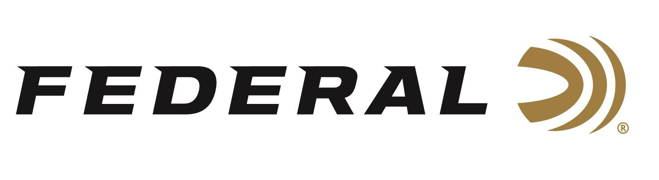

FOR IMMEDIATE RELEASE
Federal’s New Subsonic Rifle Target Loads Now Shipping

ANOKA, Minnesota – March 30, 2026– Federal Ammunition is now shipping its new Federal Subsonic target soft-point and hollow-point loads, designed to deliver effective performance and extreme accuracy at velocities that produce whisper-quiet shooting through suppressors.

Federal Subsonic

“For shooters who want noise reduction that’s real, not just relative, there’s finally a solution,” said Josh Vickers, Federal’s Centerfire Ammunition Product Manager. “Our team selected some of Federal’s most trusted and reliable target bullet designs and loaded them to muzzle velocities of 1,000 feet-per-second. At just below the speed of sound, this eliminates the harsh supersonic crack of standard-velocity ammunition that suppressors can’t silence without sacrificing the precision or performance shooters need. Our 45-70 Government, 308 Win., and 30-30 Win. and options are now shipping and are shooting great.”

Part No. / Description / MSRP
4570SUB1 / Subsonic, 45-70 Govt, 300-grain, Target Soft Point, 1,000 fps / $54.99
308SUB1 / Subsonic, 308 Win., 205-grain, Target Hollow Point, 1,000 fps / $47.99
3030SUB1 / Subsonic, 30-30 Win, 170-grain, Target Soft Point, 1,000 fps / $36.99

Federal Ammunition products are available at dealers nationwide and online. For more information on all Federal products and to sign up to receive notifications about new product availability, rebate promotions, and other brand news via email, visit www.federalpremium.com.

Press Release Contact: JJ Reich
Senior Manager – Press Relations
E-mail: media@tkghunt.com

About Federal Ammunition
Federal, headquartered in Anoka, MN, is an ammunition brand of The Kinetic Group, owned by CSG, a globally diversified industrial group based in Prague, Czech Republic. Since 1922, Federal has been a leader in ammunition innovation, delivering high-quality sporting and hunting products to shooters worldwide. With a commitment to conservation and the outdoor community, Federal continues to manufacture industry-leading ammunition that enhances the shooting experience while supporting outdoor traditions.

