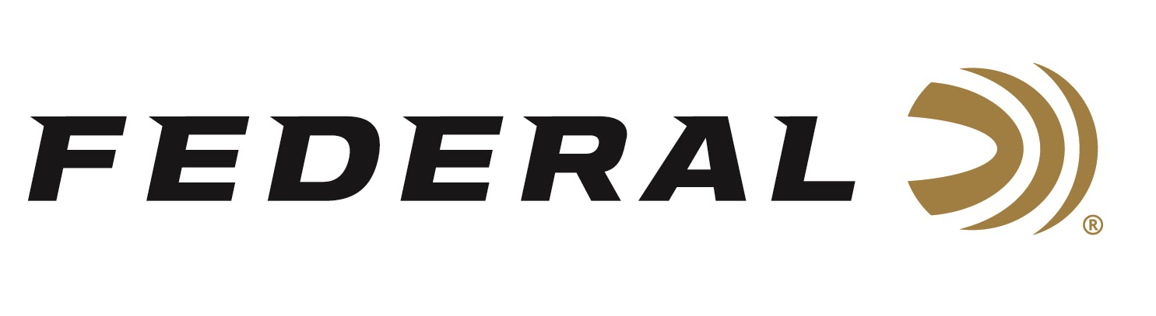

FOR IMMEDIATE RELEASE

Team Federal has Impressive Results at the 2026 Southern Grand American

ANOKA, Minnesota – March 19, 2026 – Federal Ammunition praises the strong performances of its sponsored trap shooters at the 46th Annual Southern Grand held at the Silver Dollar Shooters Club, March 9-16 in Odessa, Florida. Federal’s Weston Anderson was the Singles Co-Champ with Fiocchi’s Ricky Marshall, Jr., following a marathon shoot-off.

Anderson, from Nyssa, Oregon, was one of five shooters to shoot a perfect 200/200 to get into the shoot-off. After 5 rounds, the shoot-offs had to be called because of time restrictions, and Weston advanced to the continuation on Sunday with two others. On Sunday, after a total of 450 consecutive targets broken, Co-Champions were declared with Anderson and Marshall, Jr. sharing the title. Anderson noted that he could not have sustained his 18-box shoot-off without the new Federal All-American shells. He prefers 1 1/8 oz, 1145 fps, 8’s for singles. According to Anderson, “they crushed targets and had soft recoil that kept me on the gun round after round.” Anderson earned the Junior Championship title in Doubles and in the Preliminary events, he won the Doubles and finished Runner-Up in the Singles Class Championship, both in the Junior Division.

Hall of Famer Deborah Ohye Neilson had a memorable major winning both the High All Around and High Over All Championships in the Lady II Division. She also won both the Singles and Doubles Championships and missed the clean sweep in Lady II by finishing with second place in the Handicap event. In the Preliminary events, Neilsen added five more titles to her impressive week of trap shooting.

Federal Ammunition products, including the new All-American, are available at dealers nationwide and online. All-American features a one-piece Podium wad and high-antimony lead shot that balances hardness and density. The loads are constructed with a straight-wall hull, an inserted plastic base wad, and a striated tube for optimum performance. All-American offers a much better option than standard target loads for competitors in trap and skeet. Learn more at: All-American.

Federal Ammunition products are available at dealers nationwide and online. For more information on all Federal products and to sign up to receive notifications about new product availability, rebate promotions, and other brand news via email, visit www.federalpremium.com.

Press Release Contact: JJ Reich
Senior Manager – Press Relations
E-mail: media@tkghunt.com

About Federal Ammunition
Federal, headquartered in Anoka, MN, is an ammunition brand of The Kinetic Group, owned by CSG, a globally diversified industrial group based in Prague, Czech Republic. Since 1922, Federal has been a leader in ammunition innovation, delivering high-quality sporting and hunting products to shooters worldwide. With a commitment to conservation and the outdoor community, Federal continues to manufacture industry-leading ammunition that enhances the shooting experience while supporting outdoor traditions.

