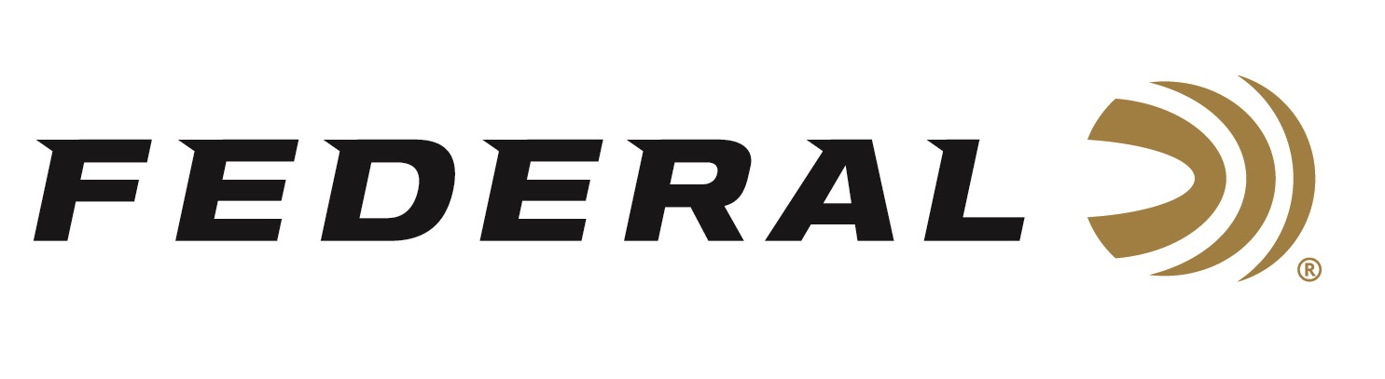

FOR IMMEDIATE RELEASE

Federal Ammunition Recognizes Team Results at the 2026 Spring Grand American

ANOKA, Minnesota – March 10, 2026 – Federal Ammunition acknowledges the strong performances of its sponsored trap shooters at the 50th Annual 2026 Spring Grand American, held February 23 to March 1 at the Tucson Trap and Skeet Club in Tucson, Arizona. The event saw a significant increase in participants from 2025, with nearly 1,500 participants competing in 2026. Team Federal delivered solid results across five championship events.

In the High Over All Championship, Westin Anderson earned the Junior Champion title by breaking 1,071 of 1,100 targets, and Ziggy Tkaczenko won the Wheelchair Champion title with 983 of 1,100 targets.

In the High All Around Championship, Ziggy Tkaczenko secured the Wheelchair Champion title after hitting 370 of 400 targets.

In the Singles Championship, Westin Anderson won the Over All Champion title with 200 of 200 targets and later broke an additional 275 straight targets in the shoot‑off. Ziggy Tkaczenko won the Wheelchair Champion title after breaking 195 of 200 targets.

In the Doubles Championship, Westin Anderson won the Junior Champion title with a score of 99 out of 100 targets, and Ziggy Tkaczenko earned the Wheelchair Champion title with 91 targets.

In preliminary events, Eric Munson broke a perfect 100 of 100 targets in Preliminary Doubles.

Federal Ammunition products, including the new All-American, are available at dealers nationwide and online. All-American features a one-piece Podium wad and high-antimony lead shot that balances hardness and density. The loads are constructed with a straight-wall hull, an inserted plastic base wad, and a striated tube for optimum performance. All-American offers a much better option than standard target loads for competitors in trap and skeet. Learn more at: All-American.

Federal Ammunition products are available at dealers nationwide and online. For more information on all Federal products and to sign up to receive notifications about new product availability, rebate promotions, and other brand news via email, visit www.federalpremium.com.

Press Release Contact: JJ Reich
Senior Manager – Press Relations
E-mail: media@tkghunt.com

About Federal Ammunition
Federal, headquartered in Anoka, MN, is an ammunition brand of The Kinetic Group, owned by CSG, a globally diversified industrial group based in Prague, Czech Republic. Since 1922, Federal has been a leader in ammunition innovation, delivering high-quality sporting and hunting products to shooters worldwide. With a commitment to conservation and the outdoor community, Federal continues to manufacture industry-leading ammunition that enhances the shooting experience while supporting outdoor traditions.

