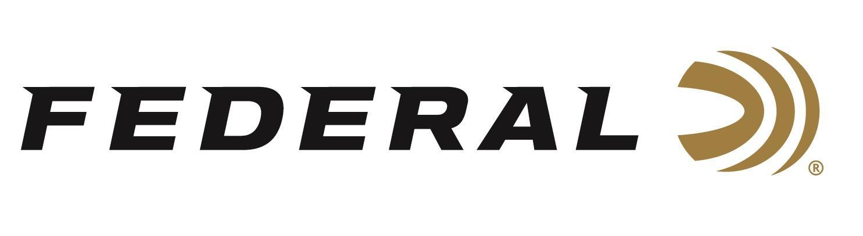

FOR IMMEDIATE RELEASE

Federal Announces New Terminal Ascent Hunting Handgun Ammo
ANOKA, Minnesota – January 19, 2026 – Federal Ammunition has announced its new Terminal Ascent Handgun ammunition line, built to deliver excellent accuracy and terminal performance for hunters who carry a handgun into the field. The three new handgun-hunting rounds feature a bonded, nickel-plated bullet design to increase weight retention, while a unique elastomer-filled nose cavity reliably expands. The new loads include 10mm Auto 203-grain, 357 Mag. 157-grain, and 44 Rem. Mag. 235-grain.
“Handgun hunters shouldn’t have to compromise when it comes to accuracy and terminal performance,” said Federal’s Handgun Ammunition Product Manager, Chris Laack. “Terminal Ascent Handgun delivers the trusted, high-performance Terminal Ascent design in powerful handgun chamberings, giving hunters confidence in the field.”
Terminal Ascent Handgun loads feature a bonded bullet design that locks the jacket to the lead core for increased weight retention, while the elastomer-filled hollow-point nose cavity is engineered to expand reliably on a wide range of game. For dependable performance in harsh hunting environments, each cartridge includes a nickel-plated case and bullet, a sealed primer to prevent corrosion, and specially selected propellants to ensure consistent ignition and accuracy in all conditions.
The new products will be displayed at the 2026 SHOT Show, January 20–23 at the Venetian Expo and Caesars Forum in Las Vegas, Nevada. Attendees of the show are encouraged to stop by Booth No. 11838 for a first-hand look at these new products and more.

Information about the new products for 2026 can be found on Federal’s brand website soon after the SHOT Show. Sign up to receive exclusive access to online promotions and news via email by visiting Federal Ammunition - Sign Up.

Federal Ammunition products are available at dealers nationwide and online. For more information on all Federal products and to sign up for notifications about new product availability, rebate promotions, and other brand news via email, visit www.federalpremium.com.

Press Release Contact: JJ Reich
Senior Manager – Press Relations
E-mail: media@tkghunt.com

About Federal Ammunition
Federal, headquartered in Anoka, MN, is an ammunition brand of The Kinetic Group, owned by CSG, a globally diversified industrial group based in Prague, Czech Republic. Since 1922, Federal has been a leader in ammunition innovation, delivering high-quality sporting and hunting products to shooters worldwide. With a commitment to conservation and the outdoor community, Federal continues to manufacture industry-leading ammunition that enhances the shooting experience while supporting outdoor traditions.

