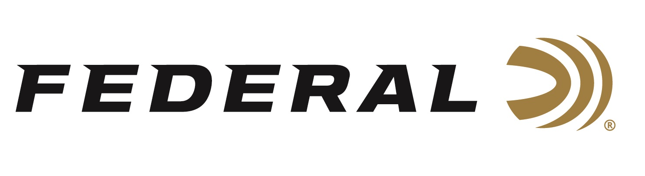
FOR IMMEDIATE RELEASE

Federal Ammunition Awards 2026 Tom Knapp Memorial Scholarships

ANOKA, Minnesota – June 29, 2026 – Federal Ammunition recently awarded the 2026 Tom Knapp Memorial Scholarships to two 4-H shooting sports teen ambassadors. The recipients, Charramaiyne Brown from Oklahoma and Isabelle Sparlin from Arizona, were presented with the scholarships at the opening ceremony of the 2026 4-H Shooting Sports National Championships held at the Heartland Events Center located in Grand Island, Nebraska, on June 21, 2026.

“All of the applicants were, once again, at the top of their class and had logged thousands of hours supporting their local communities and promoting shooting sports in their respective states,” says Jon Zinnel, Director of Community Relations for Federal Ammunition, who announced the winners on stage and virtually presented them with their awards. “The most difficult part of reviewing the scholarship applications is selecting just two athletes each year. There are so many that are deserving, which is very heartening to see and is a sign of a bright future for youth shooting sports,” said Zinnel.

In addition to the scholarships, Federal was there to celebrate the 4-H Shooting Sports Program successes and welcome nearly 800 athletes from over 40 states for a week-long shooting sports competition at the nearby Heartland Public Shooting Park.

Federal Ammunition remains the longest-tenured sponsor of the program, which introduces hundreds of thousands of new shooting sports enthusiasts to a wide array of shooting disciplines. Each year, the county programs offer safe, controlled shooting sports activities led by certified instructors to hundreds of thousands of youths nationwide.

The Tom Knapp Memorial Scholarship program, an annual initiative, was established to honor the memory of the legendary exhibition shooter Tom Knapp. Before his passing in April 2013, Knapp left an indelible mark on the shooting sports community. In 2016, Federal Ammunition and Champion Traps & Targets, in collaboration with the National 4-H Shooting Sports Committee, took up the mantle to continue this esteemed scholarship program.

Knapp, a passionate advocate for nurturing the next generation, was a respected Champion and Federal Ammunition ambassador. With the support of Knapp’s wife, Colleen, Champion extended Tom’s licensed products program to fund an endowed scholarship that annually awards $2,500 to two National 4-H Ambassadors.

Federal Ammunition products are available at dealers nationwide and online. For more information on all Federal products and to sign up to receive notifications about new product availability, rebate promotions, and other brand news via email, visit www.federalpremium.com.

Press Release Contact:
JJ Reich
Senior Manager – Press Relations
E-mail: media@tkghunt.com

About Federal Ammunition
Federal, headquartered in Anoka, MN, is an ammunition brand of The Kinetic Group, owned by CSG, a globally diversified industrial group based in Prague, Czech Republic. Since 1922, Federal has been a leader in ammunition innovation, delivering high-quality sporting and hunting products to shooters worldwide. With a commitment to conservation and the outdoor community, Federal continues to manufacture industry-leading ammunition that enhances the shooting experience while supporting outdoor traditions.

