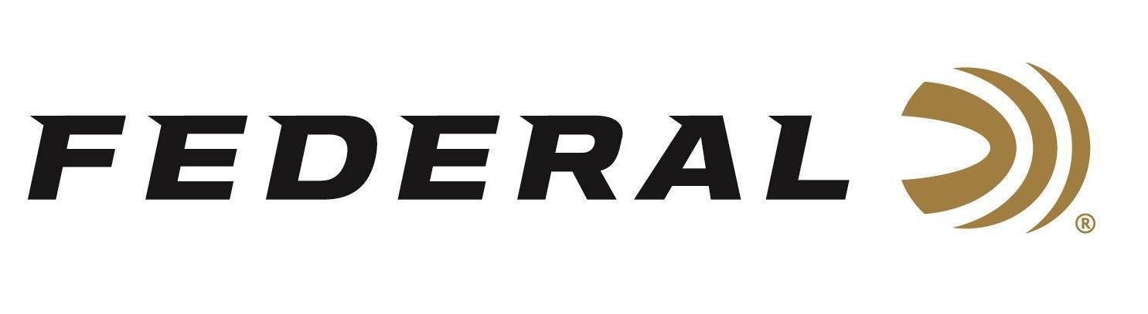

FOR IMMEDIATE RELEASE
Federal’s New Upland Steel 12-Gauge Loads Now Shipping
ANOKA, Minnesota – April 9, 2026 – Federal Ammunition is currently shipping two new 12-gauge loads in its Upland Steel shotshell lineup. Built for hunters who need consistent patterns and hard-hitting performance with non-lead shot, these new offerings are now being delivered to retailers nationwide and expand the versatility of the Upland Steel product line.
Upland Steel
“Upland Steel continues to be a go-to option for hunters who want dependable performance at a price that lets them shoot all day,” said Federal’s Shotshell Product Manager, Sam Oftedahl. “These two new 12-gauge loads in the larger shot size of No. 4 and No. 5 give hunters even more flexibility in the field, especially in areas where non-lead shot is required.”
Federal Upland Steel is designed to deliver the patterns and power hunters need for fast-flying upland birds, while maximizing the performance of steel pellets through high velocities and consistent load construction. Featuring quality steel payloads, an inserted plastic base wad, and reliable performance in the field, Upland Steel is an ideal choice for pheasants, doves, quail, grouse, and other upland game.
Part No. / Description / MSRP
USH12 4 / 12-gauge, No. 4 shot, 2-3/4-inch, 1-1/8 ounce, 25-count / $15.99
USH12 5 / 12-gauge, No. 5 shot, 2-3/4-inch, 1-1/8 ounce, 25-count / $15.99
Federal Ammunition products are available at dealers nationwide and online. For more information on all Federal products and to sign up to receive notifications about new product availability, rebate promotions, and other brand news via email, visit www.federalpremium.com.

Press Release Contact: JJ Reich
Senior Manager – Press Relations
E-mail: media@tkghunt.com

About Federal Ammunition
Federal, headquartered in Anoka, MN, is an ammunition brand of The Kinetic Group, owned by CSG, a globally diversified industrial group based in Prague, Czech Republic. Since 1922, Federal has been a leader in ammunition innovation, delivering high-quality sporting and hunting products to shooters worldwide. With a commitment to conservation and the outdoor community, Federal continues to manufacture industry-leading ammunition that enhances the shooting experience while supporting outdoor traditions.

