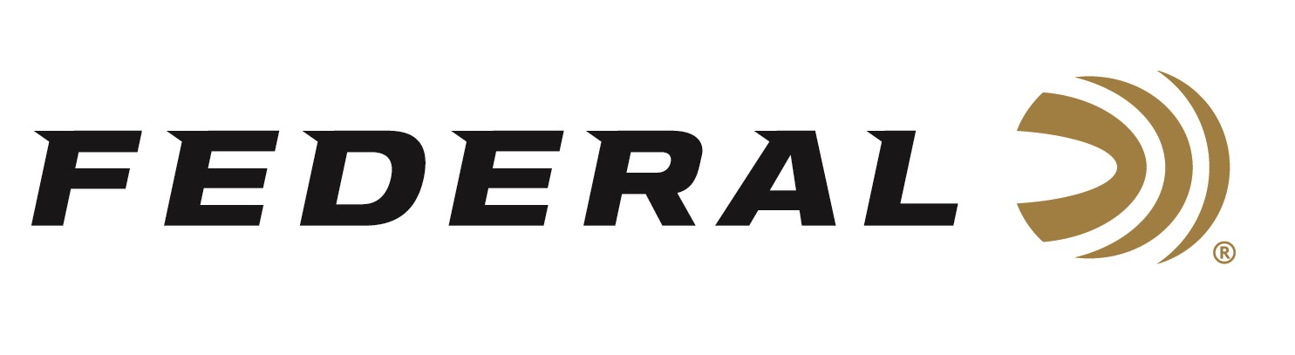

FOR IMMEDIATE RELEASE

Federal Ammunition Wins 2025 Gold Retailer Awards for Best Shotshell

ANOKA, Minnesota – May 1, 2026 – The readers of Tactical Retailer and Shooting Sports Retailer have awarded Federal Ammunition the 2025 Gold Award for Best Shotshell. These annual Readers’ Choice Awards are 100 percent reader-driven and represent the most trusted gear and brands among today’s shooting sports professionals and enthusiasts.

“These awards directly reflect the confidence that users across the shooting sports industry place in Federal shotshells,” said Federal Shotshell Manager Sam Oftedahl. “Whether in the field, on the range, or serving those in uniform, our focus has always been on delivering quality, performance, and innovation. All our target, big-game, predator, waterfowl, upland, and wild turkey loads, as well as our Personal Defense loads, are popular and well-received by our customers. Being recognized by the readers who count on our products every day is an honor and a reflection of that commitment.”

Federal has a long-standing reputation for innovative, high-performance shotshells that meet the demands of hunters, competitive shooters, and law enforcement professionals. From the legendary Gold Medal line to cutting-edge offerings like Black Cloud, Prairie Storm, and Custom Shop TSS loads, Federal continues leading the category in technology and trust.

“Federal continues to be a powerhouse in the shotshell category, and our readers have made that clear with this year’s Gold Award,” said Derrick Nawrocki, President and Publisher of Tactical Retailer and Shooting Sports Retailer. “Whether for hunting, sport shooting, or tactical use, Federal consistently delivers the performance and reliability our audience depends on. This recognition speaks to the brand’s long-standing impact and continued innovation in the field.”

The Federal Ammunition product team recently received the awards during the recent 2026 NRA Annual Meetings & Exhibits in Houston, Texas.

To learn more about new products from Federal Ammunition for 2026, visit New Products | Federal Premium.

Federal Ammunition products are available at dealers nationwide and online. For more information on all Federal products and to sign up for notifications about new product availability, rebate promotions, and other brand news via email, visit www.federalpremium.com.

Press Release Contact: JJ Reich
Senior Manager – Press Relations
E-mail: media@tkghunt.com

About Federal Ammunition
Federal, headquartered in Anoka, MN, is an ammunition brand of The Kinetic Group, owned by CSG, a globally diversified industrial group based in Prague, Czech Republic. Since 1922, Federal has been a leader in ammunition innovation, delivering high-quality sporting and hunting products to shooters worldwide. With a commitment to conservation and the outdoor community, Federal continues to manufacture industry-leading ammunition that enhances the shooting experience while supporting outdoor traditions.

