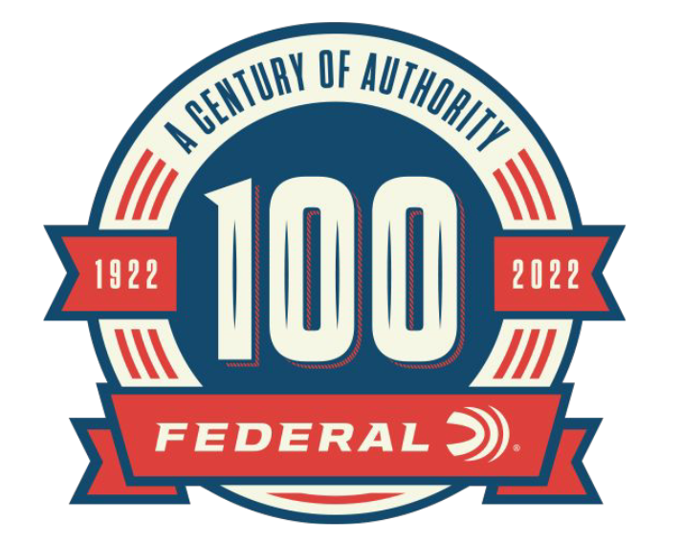

FOR IMMEDIATE RELEASE

Federal Releases Its 100th Anniversary Special Issue Magazine

ANOKA, Minnesota – February 3, 2022 – Federal Ammunition recently released a 100th Anniversary Special Issue magazine titled: Federal: Celebrating A Century of Ammo, 1922-2022. The single-issue, 104-page, full-color magazine is currently on newsstands throughout the lower 48 states at more than 14,700 stores where hunting and shooting sports publications are sold.

“This one-time-only, special-edition magazine helps communicate the story of how Federal started as an ammo manufacturing underdog to then become the industry leader in shotshell, rimfire, rifle, handgun and more,” said Federal’s VP of Marketing Jason Nash. “It’s packed with stories about ammo innovations from back then to right now, conservation initiatives spanning decades of dedication, and interesting facts taken throughout Federal’s history. Any fan of Federal will love to page through this magazine.”

Inside Federal's 100th anniversary issue, readers can explore decades of inventive product development, commitment to conservation, and rich history that define the company. Articles detail Federal’s ongoing efforts to preserve the future of hunting and shooting, a look at the company’s army of ambassadors that promote the Federal brand, along with Federal’s never-ending mission to innovate, plus much more. Product coverage includes Federal’s latest in ammunition offerings for all applications, whether for hunting, competition, warfighting, or defense. There's something for everyone at Federal.
The Federal 100th Anniversary Special Issue can also be found online direct from the publisher at: https://www.osgnewsstand.com/product/federal-2021.

For more information on all products and online services from Federal or to shop online, visit www.federalpremium.com.

Press Release Contact: JJ Reich
Senior Manager – Press Relations
E-mail: VistaPressroom@VistaOutdoor.com

About Federal Ammunition
Federal, headquartered in Anoka, MN, is a brand of Vista Outdoor Inc., an outdoor sports and recreation company. From humble beginnings nestled among the lakes and woods of Minnesota, Federal Ammunition has evolved into one of the world's largest producers of sporting ammunition. Beginning in 1922, founding president, Charles L. Horn, paved the way for our success. Today, Federal carries on Horn's vision for quality products and service with the next generation of outdoorsmen and women. We maintain our position as experts in the science of ammunition production. Every day we manufacture products to enhance our customers' shooting experience while partnering with the conservation organizations that protect and support our outdoor heritage. We offer thousands of options in our Federal Premium and Federal® lines-it's what makes us the most complete ammunition company in the business and provides our customers with a choice no matter their pursuit.

